Required tools for the job.

TerraEdit by Andrew Scheidecker.  You will need the simple but superb terraedit program, this enables you to convert your 2d 256 colour bitmap file which represents your terrain via the simple to understand palette index height field conversion.  The image showing a terraedit mesh has had the actual bmp file which in imported into it overlaid on top, the image being the actual source for the meshes shape and form, the INF image needed to be mirrored to get the right effect to show you what has happened. The whole image is palette index 0 (ground zero), the coloured pixels which make up the INF lettering are palette index 54 making each vertex which corresponds with the (x,y) co-ordinate from the bitmap rise up 54 terraedit units.  So armed with that information, we can start to imagine that if each pixel from the bitmap can have any of the possible 256 palette index positions, each vertex within our mesh can be given a height of 0 to 255 terraedit units. | 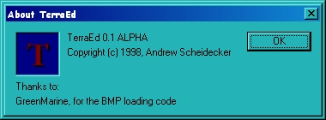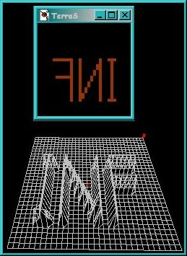
Paint program.  Any paint program will do this task for you, the basic requirements being the ability to create a windows bitmap format file which support a 256 colour palette.  Even the tools that the paint program offers can be simple to, as long as you have the ability to edit the palette and change each pixel within the image to any of the 256 possible palette combinations.  But I do recommend you find a paint program which shows the palette index number clearly, the index will end up being your terrain mesh vertex height."  I use PSP because I know all if its functions well and gave been using this program since version 1.00.  The actual colour value which sits in each palette index is of no relevance to the mesh production, it only has meaning to you, to be able to indentify which colour is sat in which index is the only important part, I suggest that you have different colours next to eachother in palette order sequence so you can easylier indentify which colour belongs where.  Finding out exactly which one is which is easy by using the dropper tool, with the dropper tool selected click and the palette on view just click on any colour within the image the corresponding palette index for that colour will be hightlighted. | 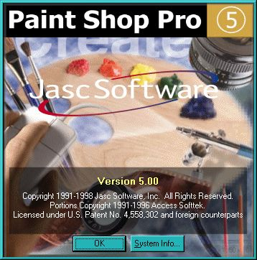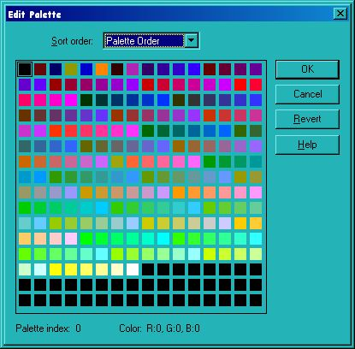
For this first experimental mesh we can create a new 256 colour bitmap of size 32x32 pixels  With the new image being 32x32 and every pixel set initially set to palette index 50 (purple) each cell would be 50 terraunits high , adding some palette index 46 (blue), index 43 (darkgray) & index 35 (pink) the resulant mesh after importing the bitmap into terraedit with a grid size of 32x32 this mesh would be produced for us.  We now understand the tools and a rough idea as to how they are going to work for us, we can set a base height by picking any palette index, say palette index 127 this means that we could cut deep gorges, rolling valleys or trenchs into our mesh to a depth of 128 by choosing a colour with a lower palette index and also raise the mesh up for slopes, hills or unclimbable mountains to a height of 128 by choosing a colour with a palette index higher than 128, the figure 128 either way would be very extreme btw.  This is the experimental part, try different palette index values maybe in steps of 4 or 8 up or down, around the bitmap and re-import the image into terraedit , try this and that, you soon will a good idea of the size and scale of things that can be done.  For me a 32 by 32 cell is enough to play around with now, you may be able to imagine what terrain features can be created now, and of course when the mesh has been imported into UnrealEd, lots more tricks can be applied...  The next stage is the planning, planning and more planning I can't stress enough that the next part is so important it can mean the difference between success or back to our image template or just a grid scale change and a re-import. | 